**A PROJECT REPORT**

**ON**

**“Orphanage Home Maintains System”**

SUBMITTED IN PARTIAL FULFILLMENT OF THE REQUIREMENTS FOR THE AWARD OF

**DIPLOMA IN**

**COMPUTER ENGINEERING DEPARTMENT**



**SUBMITTED TO**

**MAHARASHTRA STATE BOARD OF TECHNICAL EDUCATION, MUMBAI**

**SUBMITTED BY**

| **Name of Student(s) (Full Name)** | **Enrollment No.** |
| --- | --- |
| 1. **Pokharkar Anuja Suresh** | **08** |
| 1. **Gawade Vaishinavi Pradip** | **24** |
| 1. **Dongare Ankita Nivrutti** | **37** |
| 1. **Pansare Priyanka Sunil** | **60** |

**GUIDED BY**

**Full name of Guide**

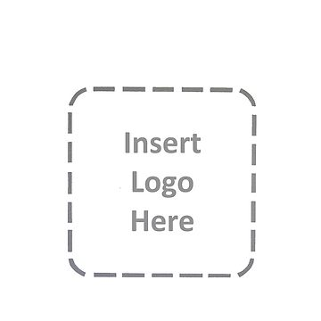

**NAME OF YOUR INSTITUTE**



**NAME OF YOUR INSTITUTE**

**CERTIFICATE**

**This is to Certify that the project report entitled “Orphanage Home Maintains System” Was**

**successfully completed by Student of sixth semester Diploma in (Computer Engineering).**

| 1. **Pokharkar Anuja Suresh** | **08** |
| --- | --- |
| 1. **Gawade Vaishinavi Pradip** | **24** |
| 1. **Dongare Ankita Nivrutti** | **37** |
| 1. **Pansare Priyanka Sunil** | **60** |

**in partial fulfillment of the requirements for the award of the Diploma in Computer Engineering and submitted to the Department of Computer Engineering of Name of institute work carried out during a period for the academic year 2022-23 as per curriculum.**

| **Name of Guide** | **Name of HOD** |
| --- | --- |
| **Guide** | **HOD** |
|  |  |
|  | **Name of Principal** |
| **External Examiner** | **Principal** |

**ACKNOWLEDGEMENT**

I would like to express my special thanks of gratitude to my project guide << Name of guide>> as well as our principal << Name of Principal >> who gave me the golden opportunity to do this wonderful project on the topic << project title >>, which also helped me in doing a lot of research and i came to know about so many new things I am really thankful to them.

Secondly I would also like to thank my parents and friends who helped me a lot in finalizing this project within the limited time frame.

| Date : | << Your Name >> |
| --- | --- |
| Place : | << Roll no >> |
|  | << Class >> |

**ABSTRACT**

There are more than 40 charitable organizations which have put in place children homes and orphanages to help accommodate homeless children and orphans. These children are homeless due t family matters. Daily activities which happen include: sports, learning, guiding and counseling, visits by donors, volunteers or well-wishers, and other institutions or organizations. In a typical orphanage, records are usually kept for future reference, retrieval, reproduction, and easy management. The daily activities, schedules and events are also recorded. For instance, if there is need to know the population of the orphanage/ children home, one may need to count the records obtained from different files that contain papers with information. The main objective of this project was to design and develop a new system of managing information in these orphanages. The system helps the clerk in reducing paperwork and enhance tidiness in record keeping since the existing one uses manual keeping i.e. use of files and papers. It also reduces costs incurred in purchasing files and papers for individual entities. The system manages records of children, guardians/caretakers, donors, sponsors, volunteers, adoptive-parents and adoption. The system allows the user to add, modify, delete and print the entry records. It also provides tracking the progress for children that have been adopted from these orphanages, which other systems don’t do. The study examined various aspects of objectives and analyzed them and related to the literature and data which was collected using interviews, questionnaires and observation. It focused on both qualitative and quantitative approach as the methodology.

**TABLE OF CONTENTS**

|  | **CONTENTS** |  |
| --- | --- | --- |
|  | **ABSTRACT** | 4 |
|  | **LIST OF TABLES** | 6 |
|  | **LIST OF FIGURES** | 7 |
| **1.0** | **INTRODUCTION** | **1** |
|  | 1.1 Background and Basics | 1 |
|  | 1.2 Goals and Objectives | 2 |
| **2.0** | **LITERATURE SURVEY** | **3** |
|  | 2.1 Literature Survey | 3 |
|  | 2.2 Problem Definition | 5 |
| **3.0** | **DESIGN PROCEDURE** | **6** |
|  | 3.1 Algorithm | 6 |
|  | 3.2 Architecture / Block Diagram | 7 |
| **4.0** | **METHODOLOGY** | **11** |
|  | 4.1 Proposed Methodology of solving Identified problem | 11 |
|  | 4.2 Action Plan | 12 |
| **5.0** | **RESOURCES AND CONSUMABLES** | **14** |
|  | 5.1 Software Requirements | 14 |
|  | 5.2 hardware Requirements | 16 |
| **6.0** | **CONCLUSION AND FUTURE SCOPE** | **17** |
|  | 6.1 Conclusion | 17 |
|  | 6.2 Future Enhancement | 17 |
| **7.0** | **REFERENCES AND BIBLOGRAPHY** | **18** |

**LIST OF TABLES**

| **Table No.** | **Title** | **Page No.** |
| --- | --- | --- |
| Table 4.2.1 | Action Plan | 13 |
|  |  |  |
|  |  |  |

**LIST OF FIGURES**

| **Figure No.** | **Title** | **Page No**. |
| --- | --- | --- |
| Figure 3.1.1 | Waterfall Model | 6 |
| Figure 3.2.1 | Block Diagram | 7 |
| Figure 3.2.2 | Use Case Diagram | 9 |
| Figure 3.2.3 | Activity Diagram | 10 |
| Figure 5.1.1 | XAMPP Control Panel | 16 |

**1. INTRODUCTION**

**1.1 Background and basics**

An orphanage is a residential child care facility intended to care for children from the time of their admission until their maturity or emancipation, and which holds itself out as an acceptable or superior substitute for the children's families. Orphans are children whose biological parents are deceased or otherwise unable or unwilling to care for them.

In recent years, the subject of an orphan child has caused a great deal of worry and concern. It's a problem that affects a lot of people in society.

Due to the lack of an effective record management system, it has been particularly challenging to monitor and track orphans who have been adopted by foster parents. Due to the high number of adolescent victims, it is implied that orphans lack siblings or any other kind of family, home, or sense of identity. They lack the standard family atmosphere and the necessities of life as a result, and the broader public largely ignores them as a result. Being an orphan is already a terrible situation, but when you add the lack of social and basic facilities, complete disregard, and insensitivity of the general population, it becomes intolerable.

As a result, keeping accurate records of orphans and the actions taken in their care is critical to managing orphanage facilities. These records are also useful for future research. The technology also allows flexibility in information access and retrieval.

In light of this, the purpose of this article is to design and create a software that will allow the administration of the House of Hope orphanage to maintain effective, accessible, and precise records of the orphans.

Orphanage Home Maintains System is useful for both administrative and service personnel. In the existing system, everything is carried out manually. It costs a lot of money and takes a lot of time. Our Orphanage Home Maintains System handles a variety of orphanage-related tasks. This software primarily consists of two parts.

1. User Module
2. Administrator Module

For each orphan or elderly person, we can register in the software as their guardian. The administration will supply the authentication code and ID. In this project, an administrator can manage orphan details and make decisions regarding records, such as deleting any details. An administrator is also authorized to create a token for the registration of a guardian, just as a guardian is authorized to do the same for an orphan or an elderly person. This system offers a straightforward user interface for the upkeep of orphan or elderly person information. It makes it simple for old age homes orphanages to keep track of their residents' records. With a manual system, it would be challenging to accomplish this goal because the information is dispersed, often redundant, and gathering pertinent data can take a lot of time.

Orphange Home Maintains System is a computerized system used to create and store accurate information about the identities of orphans in an orphanage. It further provides a digital repository for accurate and timely manipulation of adoption and admittance process in orphanage.

**1.2 Goals and Objectives**

Any organization would find it laborious to monitor and keep the details of the orphans or elderly without an orphanage management system. The specifics of the orphans, including their past, educational background, personal information, and all information pertaining to their medical reports, will be stored in the orphanage management system.

The goal of the orphanage management system is to give administrators of any organization the ability to update and find out personal information about an orphan or elderly person, as well as amend such information. Additionally, it will make it easier to maintain all of an elderly person's orphan's or other vulnerable person's details, including their name, address, phone number, date of birth, and medical records. Therefore, all of their information will be accessible in a matter of seconds.

Overall, it will make managing information about orphans or elderly people easier for any organization's administrator and service staff. This SRS document's primary goal is to illustrate the project Orphanage management system's requirements. Its goal is to assist any organization in maintaining and managing the personal information of its students.

**2. LITERATURE SURVEY**

**2.1 Literature Survey**

**Paper1:**

**Title:** Design and Development of an Orphans Record System

**Description:** The primary goal of this project was to offer a dependable solution to the manual record system issues that BASOVCA faced in trying to manage the record system operations for their OVCs. The goal of finding a workable solution to the issues caused by the manual system of record administration was effectively accomplished. Although there were some difficulties during the data gathering process because some of the respondents refused to cooperate and support the research. However, a record management system for BASOVCA is possible if the procedures described in this research paper are implemented using the proper programming language. However, the paper only addressed the design component; it also suggests additional research by motivated scholars.

**Paper2:**

**Title:** Orphans Record Management and Tracking System for House of Hope Orphanage in Jos, Plateau State

**Description:** Through the design and development of a programme, the management of the House of Hope Orphanage will be able to maintain adequate, accessible, and accurate records of the orphans. For the purpose of tracking and monitoring child admission and adoption within the orphanage, the suggested programme was created as a standalone application utilizing the Microsoft.net framework. The system was created using MYSQL, OLedb adaptor, and Microsoft Visual Basic.net. The system has a graphical user interface, and Windows 7, 8, and 10 have all been used to test and implement it. The test's outcome was 85% correct and effectively remedied the issues with the current system. Future work should incorporate an Internet of Things (IOT) using RFID technology to further improve it.

The effort has been successful in creating a system that keeps track of court case updates. The system has been put in place to make the registration and verification of orphans' information simple and efficient. To the best of our knowledge and abilities, we were able to automate the current system, making it simple to access and quick to retrieve data. Future work should incorporate an Internet of Things (IOT) using RFID technology to further improve it.

**Paper3:**

**Title:** Digitalized Orphanage Home Management System Consisting Of Mass data Entries **Description:** The orphanage home management information system that is proposed in this paper's paper will replace the current manual (paper) management system with a digital (computerized) management system. The study has so far examined the enormous significance of computer information systems (IS) and how they are used to manage information in orphanages. As a result, this new system will provide the Ghanaian orphanage homes with a user-friendly application system that can be adjusted to suit user needs. Information System (IS) is a database system that is dynamic and adaptable and can be used with maximum performance.

**Paper4:**

**Title:** Orphanage Home Management System Using Cloud With Data Anonymization

**Description:** Cloud computing is fast growing a popular option for renting of computing and storage infrastructure services. Cloud computing is a computing resource in which tasks are assigned to a different set of connections, services and software that can be accessed over internet. This paper proposes the usage of cloud computing in Orphanage Home Management System. This paper identifies the importance of privacy in cloud computing and provides privacy preserving technologies used in cloud computing. Privacy should be built into every stage so that it can be implemented in cloud environment for orphanage management system. Lots of techniques for anonymization have been implemented, but still there is a fear of security breach. So we introduced Spectral anonymization here to provide perfect privacy protection and analytic utility. The great challenge for an anonymization scheme is to provide adequate privacy protection while minimally affecting the data‟s analytic utility.The concept of spectral anonymization is therefore attractive due to its simplicity and power.The proposed method achieves good results and reduces the overall execution time. We further analyze the query execution process to reduce the overall execution time.

**2.2 Problem Definition**

Orphanage management System is the process of collecting, processing, and storing transmitting relevant information to support the management operations inany organizations. Where it helps to provide accurate and timely information necessary to facilitate the decision-making process and enable the organization's planning, control, and operational functions to be carried out effectively.

1. **DESIGN PROCEDURE**

**3.1 Algorithm and Model Used**

We have used the Waterfall model for developing the system. The classical waterfall model is the basic software development life cycle model. It is very simple but idealistic. Earlier this model was very popular but nowadays it is not used. But it is very important because all the other software development life cycle models are based on the classical waterfall model.

The classical waterfall model divides the life cycle into a set of phases. This model considers that one phase can be started after the completion of the previous phase. That is the output of one phase will be the input to the next phase. Thus the development process can be considered as a sequential flow in the waterfall. Here the phases do not overlap with each other.

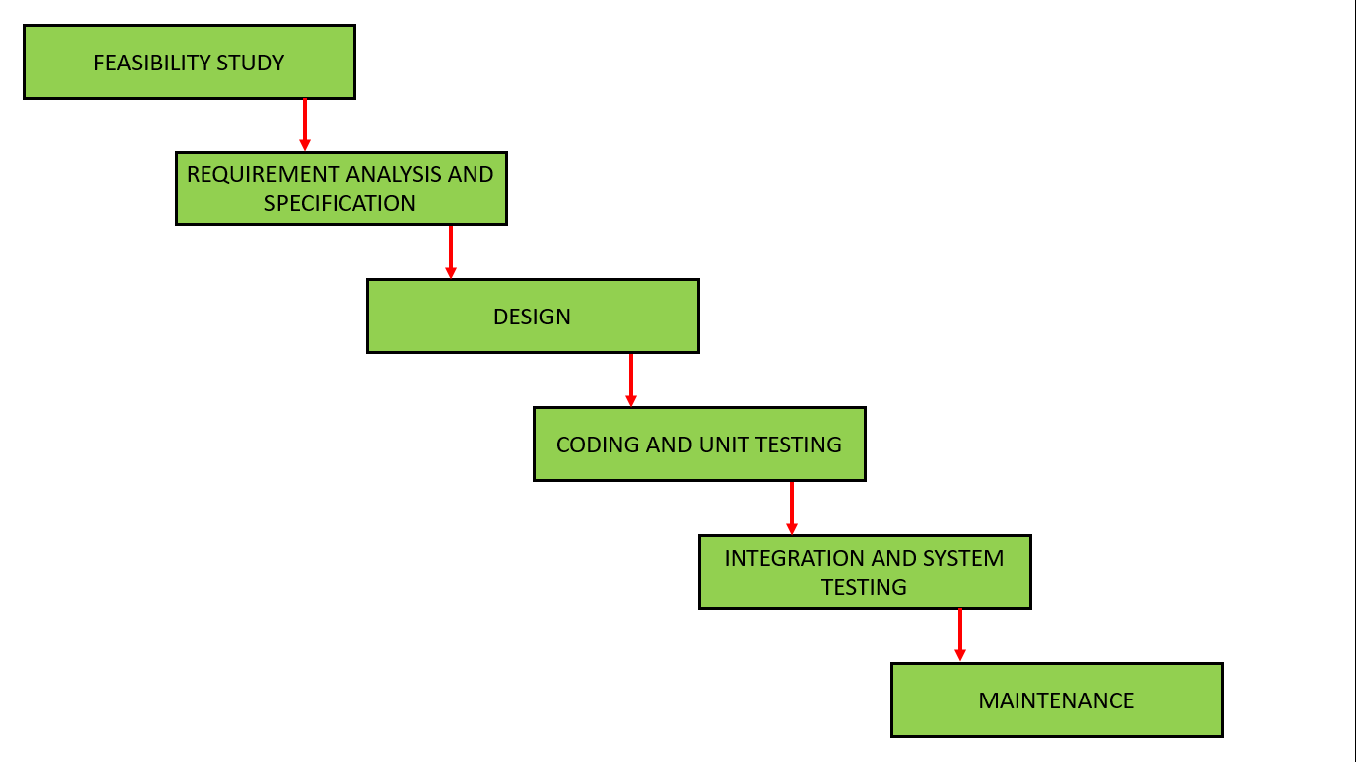

Fig. 3.1.1 Waterfall Model

**Algorithm :**

Step1:Read Input Job

Step2: Identify set of data objects necessary to execute the job.

Step3: Compute similarity measure of data objects with semantic concepts.

Step4: Identify the semantic concept with respect to similarity measure.

Step5: Retrieve the location of datasets from the indexed results.

Step6: Return the results.

**3.2 Architecture / block Diagram**

An architecture diagram is a graphical representation of a set ofconcepts, that are part of an architecture, including their principles,elements and components.

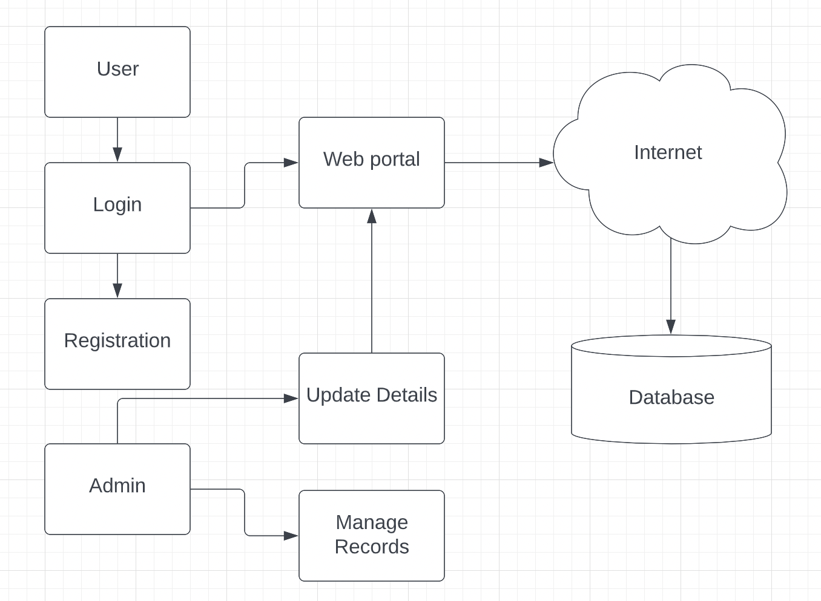

Fig. 3.2.1 Block Diagram

**UML Diagrams :**

UML is a standard language for specifying, visualizing, constructing, and documenting the artifacts of software systems. UML was created by the Object Management Group (OMG) and UML 1.0 specification draft was proposed to the OMG in January 1997. OMG is continuously making efforts to create a truly industry standard. UML stands for Unified Modeling Language. UML is different from the other common programming languages such as C++, Java, COBOL, etc.UML is a pictorial language used to make software blueprints. UML can be described as a general purpose visual modeling language to visualize, specify, construct, and document software system. Although UML is generally used to model software systems, it is not limited within this boundary. It is also used to model non-software systems as well. For example, the process flow in a manufacturing unit, etc. UML is not a programming language but tools can be used to generate code in various languages using UML diagrams. UML has a direct relation with object oriented analysis and design. After some standardization, UML has become an OMG standard.

Use Case Diagram :

​​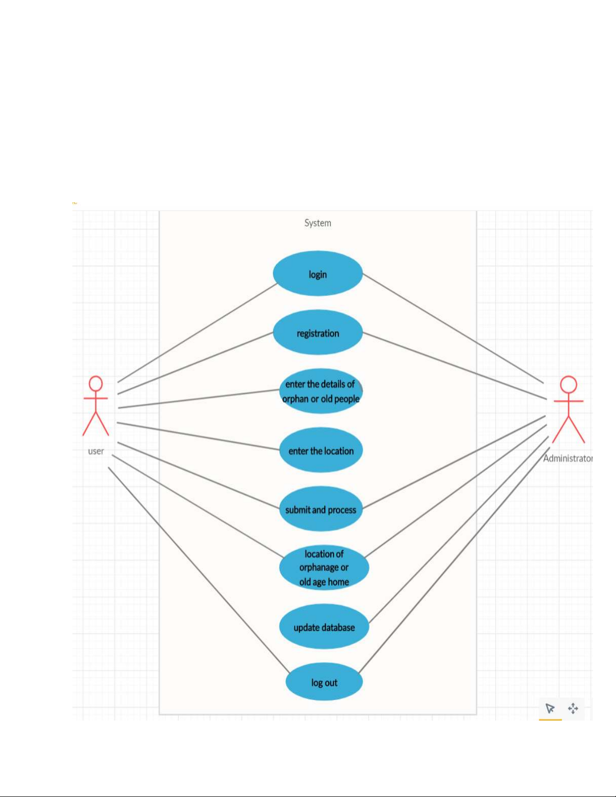

Fig. 3.2.2 Use Case Diagram

Activity Diagram :

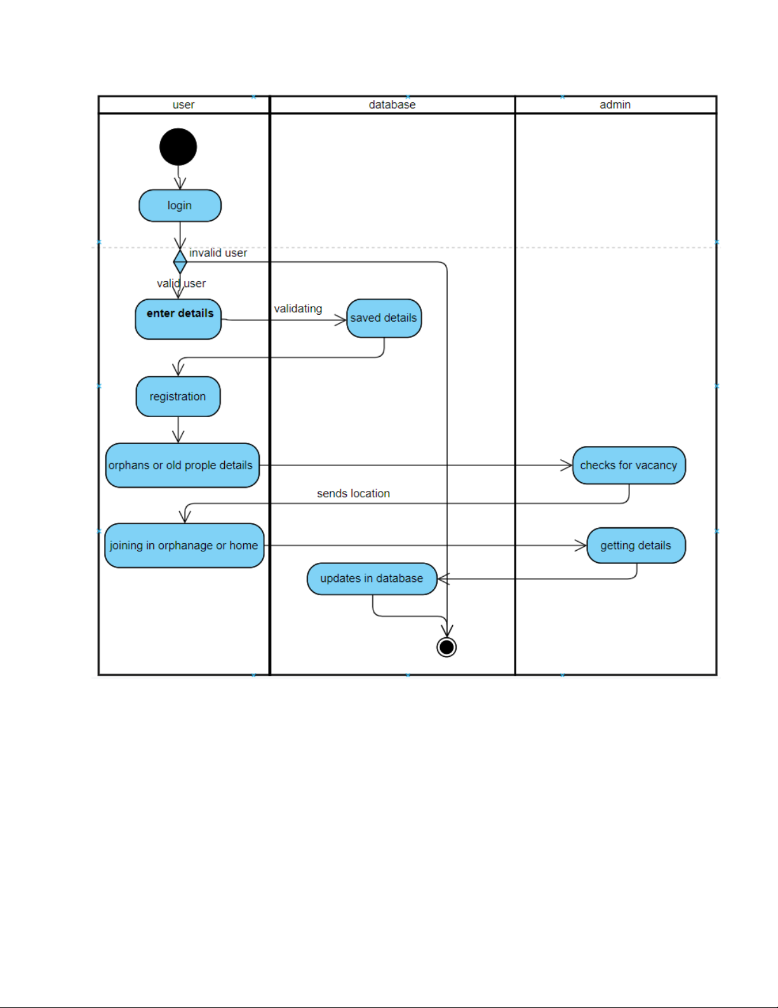

Fig. 3.2.3. Activity Diagram

1. **METHODOLOGY**

**4.1 Proposed Methodology**

Observation and interview methods were employed for data gathering. The Unified Modeling language was used for modeling the proposed orphanage record system. The proposed system was built as a standalone application with the.Net Framework. The User interface of the system was built using HTML,CSS, JAVASCRIPT. PHP is used as a server side scripting language. The data generated from the application is stored in the MYSQL database. The above diagram shows the project's process. There are two main portals in the project: User, Admin. After successfully registering, the User will log in using his or her credentials to view the fine print of the country's orphanages and to obtain the official policies and procedures of India's adoption agency as well as the legal process to adopt a child. In addition to that, the user will donate to an orphanage or sponsor a child. The admin can see every user. Admin has the privilege to update the data in the database. For the adoption process admin will grant the permissions. In order to generate useful information, data needs to be collected, stored and processed. Basically,the term database system is described as a data processing system dealing with a database, i.e. a computer-base system whose overall purpose is to record and maintain large scale data which may support the operations of multiple users (community of users). The aim of a database is to provide convenient access to common data for a wide variety of users and user needs. Keeping the orphanage home’s information in a database has a number of reasons:It will provide them with a centralized control of operational data, the amount of redundancy in the stored data can be reduced, the stored data can be stored, problems of inconsistency in the stored data can be avoided and security restriction can be applied.

* DRAWBACKS OF THE OLD (PAPER) SYSTEM

The current system involves the manual filing of information, there are several problems that are state for the current system:Lack of security,Manual filing system has low data retrieval, Dataconsistency and No backup and recovery.

* PROPOSED METHOD

There are some objectives that have to be achieved through the system and they are:Secure system, Faster data processing and accessing, Data integrity and Backup and recovery.

**4.2 Action plan**

| Sr. no | Details of Activity | Planned Start Date | Planned finish Date | Name of Responsible Team members |
| --- | --- | --- | --- | --- |
| 1 | Problem Identification (Search project topics/title related to course)/ Selection of topic | 14/12/2020 | 18/12/2020 |  |
| 2 | Industrial Survey and Literature Review (Search & collect information related to selected topic) | 19/12/2020 | 26/12/2020 |  |
| 3 | Completion of Capstone project topic/title Proposal | 28/12/2020 | 01/01/2021 |  |
| 4 | Analyze & finalize collected data For Capstone Project report. | 02/01/2021 | 08/01/2021 |  |
| 5 | Finalize tentative Design. | 09/01/2021 | 15/01/2021 |  |
| 6 | Report Writing for work done in fifth semester | 16/01/2021 | 22/01/2021 |  |
| 7 | Presentation and Defense for work done in fifth semester | 23/01/2021 | 29/01/2021 |  |

Table 4.2.1 Action plan

1. **RESOURCES AND CONSUMABLES**

**5.1 Software requirements**

a) PHP **-** A general-purpose programming language called PHP is particularly well suited for server-side web development, since PHP typically runs on a web server. The HTML source document contains integrated PHP code. The PHP runtime executes any PHP code found in a requested file, typically producing dynamic web page content. Additionally, it can be used for client-side GUI programmes and scripting on the command line. Numerous web servers, operating systems, and relational database management systems support PHP for deployment (RDBMS). It is free to use, and the PHP Group offers the whole source code so that users can create, adapt, and expand it for their own purposes. Running MySQL and building a database and table with data that will be used by our website after Apache and PHP comes next.

b) MySQL - Relational database management system (RDBMS) MySQL allows multiple users to access various databases while running as a server. However, we will end up with a database name, a user name, and a password. The procedure of setting up a MySQL database differs from host to host. We must first create a table before using our database. In phpMyAdmin, creating a table is as easy as typing the name, choosing the amount of fields, and clicking the "go" button. Executing straightforward SQL commands in phpMyAdmin is another method for establishing databases and tables. This technique was employed to build our database and tables.

c) APACHE - The Apache HTTP Server is a web server software notable for playing a key role in the initial growth of the World Wide Web. In 2009 it became the first webserver software to surpass the 100 million web site milestone. Apache is developed and maintained by an open community of developers under the auspices of theApache Software Foundation. Since April 1996 Apache has been the most popularHTTP server software in use. As of November 2010 Apache served over 59.36% of all websites and over 66.56% of the first one million busiest websites

d) XAMPP - XAMPP is a small and light Apache distribution containing the most common web development technologies in a single package. Its contents, small size, and portability make it the ideal tool for students developing and testing applications inPHP and MySQL. XAMPP is available as a free download in two specific packages: full and lite. While the full package download provides a wide array of development tools, XAMPP Lite contains the necessary technologies that meet theOntario Skills Competition standards.

e) Obtaining and Inastalling XAMPP - As previously mentioned, XAMPP is a free package available for download and use for various web development tasks. All XAMPP packages and add-ons are distributed through the Apache Friends website at the address:http://www.apachefriends.org/. Once on the website, navigate and find theWindows version of XAMPP and download the self-extracting ZIP archive. After downloading the archive, run and extract its contents into the root path of a harddisk or USB drive. For example, the extract path for a local Windows installationwould simply be C:\. If extracted properly we will notice a new xampp directory inthe root of your installation disk. In order to test that everything has been installed correctly, first start the Apache HTTP Server by navigating to the xampp directoryand clicking on the apache_start.bat batch file.Next we will test if the server is running correctly by opening an internet browserand typing http://localhost/ into the address bar. If configured correctly, we will bepresented with a screen similar to that of the one below. In order to stop all Apache processes we do not close the running terminalapplication, but instead run another batch file in the xampplite directory calledapache_stop.bat.

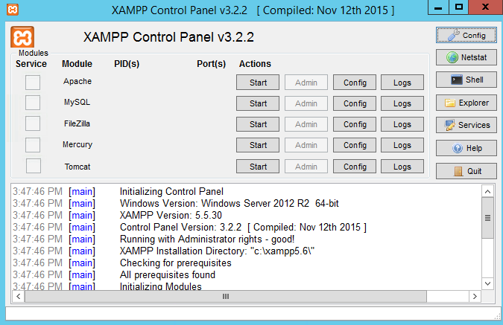

Fig. 5.1.1. XAMPP Control Panel

OS : Windows 7 and Above

**5.2 Hardware Requirements**

* Hard Disk : 250GB and Above
* RAM : 4GB and Above
* Processor : Dual core and Above

1. **CONCLUSIONS AND FUTURE SCOPE**

**6.1 Conclusion**

Thus we have created a software system to easily manage all the activities of an orphan home.

The system bring about the following:

1. Efficiency in operations at the highest level due to the relational database prepared by the HTTP server.

2. It will enhance timeliness, accuracy, reliability and above all easy access to data and information.

3. It will accelerate the decision making mechanism which will turn the whole system into modern and appreciative.

4. The system will help to reduce the high rate of labor using its high level of automation and independence.

**6.2 Future Enhancement**

Privacy preservation can be achieved by searching and transferring the contents based on the public/private sharing of posts and by using Pseudo identities.Posts will be filtered on a timely manner. The results can be produced in user graphical representation, overall graphical representation and show the relationship between the user and rated user.

1. **REFERENCES AND BIBLIOGRAPHY**
2. A. Tiwari,S. Shinde, H. Salunke,Prof, R. Barve ‘HOME FOR ORPHANS (ORPHANAGE APPLICATION)’, *International Research Journal of Engineering and Technology (IRJET),*2021
3. M. A. Haruna,K. M. Yashi, Z. Y. Shehu,S. Abdulganiyu, ‘Design and Development of Orphan record System’, *Nigerian Journal of Management Technology & Development ,*2017
4. O. Jude,A. E. O., Z. Y. Shehu,S. Abdulganiyu, ‘Orphans Record Management and Tracking System for House of Hope Orphanage in Jos, Plateau State’, *International Journal of Innovative Science and Research Technology ,*2019
5. K. E. Ewald,H. Abubakar,C. Kenneth,S. Esther, ‘DIGITALIZED ORPHANAGE HOME MANAGEMENT SYSTEM CONSISTING OF MASS DATA ENTRIES’, *International Journal of Industrial Electronics and Electrical Engineering ,*2020
6. Mr. N. Jayapandian,A. Sowntharya,U. kasthuri, ‘Orphanage Home Management System Using Cloud With Data Anonymization’, *International Journal of Applied Engineering Research ,*2015

**Links :**

* <https://www.w3schools.com/php/php_install.asp>
* <https://www.w3schools.com/php/php_syntax.asp>
* <https://www.javatpoint.com/mysql-tutorial>
* <https://www.javatpoint.com/mysql-create-database>
* https://www.javatpoint.com/mysql-select-database
* https://www.apachefriends.org/download.html
* https://en.wikipedia.org/wiki/PhpMyAdmin
* <https://www.tutorialrepublic.com/php-tutorial/php-get-started.php>
* <https://www.geeksforgeeks.org/connect-php-to-mysql/>
* https://code.tutsplus.com/tutorials/how-to-use-php-in-html-code--cms-34378